**KWAME NKRUMAH UNIVERSITY OF SCIENCE AND TECHNOLOGY, KUMASI**

**COLLEGE OF ENGINEERING**

**FACULTY OF MECHANICAL AND CHEMICAL ENGINEERING**

**DEPARTMENT OF MECHANICAL ENGINEERING**

**BSc. MECHANICAL ENGINEERING**

**FIRST YEAR**

**ENGINEERING TECHNOLOGY**

**MECHANICAL ENGINEERING LABORATORY**

**FLUIDS LABORATORY**

**EXPERIMENT PERFORMED ON VENTI METER**

**WRITTEN BY FAGORALA NIFEMI OLUWATOSIN**

**IND NO 3156920**

**14/03/2021**

Table of Contents

2.0 INTRODUCTION 6

3.0 THEORY 7

3.1 Venturi Meter 8

3.1.1 The Orifice Meter 11

3.1.2 The Variable Area Meter (Rotameter) 12

4.0 EXPERIMENTS TO BE PERFORMED 14

4.1 Calculation of the coefficien of efflux of the calibrated diaphragm Aim of the Experiment: 14

4.2 Calculation of the coefficien of efflux of the venturi meter Aim of the Experiment: 15

4.3 Calibration of the variable area flowmeter 16

4.4 Measurement methods comprosion 16

4.5 Comparing the load losses 17

Table of figures

Figure 1: Flow measurement apparatus 8

Figure 2: Venturi meter 9

Figure 3: International standard shapes for venture nozzle 13

Figure 4: The co-efficient of discharge of a venturi meter 13

Figure 5: Cutaway view of the orifice meter The co-efficient of discharge is 0.62-0.67 for orifice meter. 14

Figure 6: The co-efficient of discharge of an orifice meter. 14

Figure 7:Figure 7. (a) The approximate velocity profiles at several planes near a sharp-edged orifice plate. Note: the jet emerging from the hole is somewhat smaller than the hole itself; in highly turbulent flow the jet necks down to a minimum cross section at 15

Figure 8: (a,b) Rotameter 16

Table of equations

Equation 1 9

Equation 2 11

Equation 3 11

Equation 4 11

Equation 5 11

Equation 6 11

Equation 7 12

Equation 8 16

Equation 9 17

Equation 10 18

Equation 11 19

Table of tables

Table 1: Calculation of the coefficient of efflux of the calibrated diaphragm 17

Table 2: Calculation of the coefficient of efflux of the venturi meter 19

Table 3: Calibration of the variable area flowmeter 20

Table 4: Comparing the load losses 21

1. **OBJECTİVE**

The main objectives of this experiment is to obtain the coefficient of discharge from experimental data by utilizing venture meter and, also the relationship between Reynolds number and the coefficient of discharge.

# 2.0 INTRODUCTION

There are many different meters used to measure fluid flow: the turbine-type flow meter, the rotameter, the orifice meter, and the venture meter are only a few. Each meter works by its ability to alter a certain physical property of the flowing fluid and then allows this alteration to be measured. The measured alteration is then related to the flow. The subject of this experiment is to analyze *the features of certain meters.*

# 3.0 THEORY

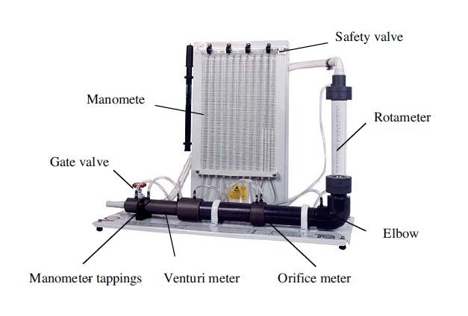

Figure 1: Flow measurement apparatus

The flow measurement apparatus consists of a water loop as shown above figure. The supple line is connected to a gravimetric hydraulic bench. The flow rate controlled by a gate valve located at the discharge side of the hydraulics bench. A venture meter, wide-angle

diffuser, orifice meter and rotameter are arranged in series. Pressure taps across each device are connected to vertical manometer tubes located on a panel at the rear of the apparatus. The discharge from the apparatus is returned to the hydraulics bench.

## 3.1 Venturi Meter

A [venturi meter](http://www.nptel.ac.in/courses/112104118/lecture-15/15-1_mesure_flow.htm) is a measuring or also considered as a meter device that is usually used to measure the flow of a fluid in the pipe. A Venturi meter may also be used to increase the velocity of any type fluid in a pipe at any particular point. It basically works on the principle of Bernoulli's Theorem. The pressure in a fluid moving through a small cross section drops suddenly leading to an increase in velocity of the flow. The fluid of the characteristics of high pressure and low velocity gets converted to the low pressure and high velocity at a particular point and again reaches to high pressure and low velocity. The point where the characteristics become low pressure and high velocity is the place where the venturi flow meter is used.

The Venturi meter is constructed as shown in Figure 2. It has a constriction within itself. The pressure difference between the upstream and the downstream flow, Δ*h*, can be found as a function of the flow rate. Applying Bernoulli’s equation to points  and  of the Venturi meter and relating the pressure difference to the flow rate yields.

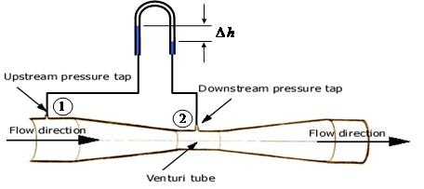

Figure 2: Venturi meter

Assume incompressible flow and no frictional losses, from Bernoulli’s Equation

* 1. *V* 2 *P V* 2

1  1  *Z*1  2  2  *Z*2

(1)

** 2*g * 2*g*

Equation 1

Use of the continuity Equation Q = A1V1 = A2V2, equation (1) becomes

*P*  *P*

*V* 2 

 *A* 2 

1 ** 2  *Z*1  *Z* 2  2 1  2  

(2)

2*g* 

 *A*1  

Equation 2

*V*2 

1

1 



2*g*



 *P*  *P*

2

**

 (*Z*  *Z* 

1 2

) 

 

2

*A*

2

 *A*1 



(3)

Equation 3

Theoretical

*A*2

1   2 

 *A*

2

2*g*



 *P*  *P*

1 2

**

 (*Z*  *Z* 

1 2

) 



 *A*1 

*Qtheo*

 *A*2 *V*2 

(4)

Equation 4

The term

*P*1  *P*2  (*Z*

** 1

* *Z*2

) represents the difference in piezo metric head ( *h* ) between

the two sections 1 and 2. The above expression for V2 is obtained based on the assumption of one-dimensional frictionless flow. Hence the theoretical flow can be expressed as

*A*2

2*g*(*h*)

1 

 *A*

2

 *A*1 

2 

*Qtheo*

 *A*2 *V*2 

(5)

Equation 5

Thus,

* 1. 

2*g**h*





1

 2

*A*

2 *A*2

−

1



1 



*theo* (6)

Equation 6

Because of the above assumptions, the actual flow rate,

*Qact*

differs from

*Qtheo*

and the

ratio between them is called the discharge coefficient, Cd which can be written as

*C*  *Qact*

(7)

*d*

*Q*

*theo*

Equation 7

The value of Cd differs from one flowmeter to the other depending on the flowmeter geometry and the Reynolds number. The discharge coefficient is always less than due to various losses (friction losses, area contraction etc.).

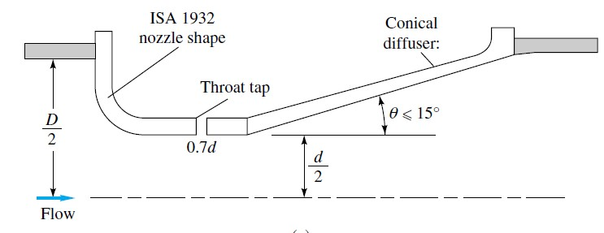

Figure 3: International standard shapes for venture nozzle

The modern venturi nozzle, Fig. 3, consists of an ISA 1932 nozzle entrance and a conical expansion of half-angle no greater than 15°. It is intended to be operated in a narrow Reynolds-number range of 1.5 x 105 to 2 x 106. The co-efficient of discharge is 0.95-0.98 for venturi meter.

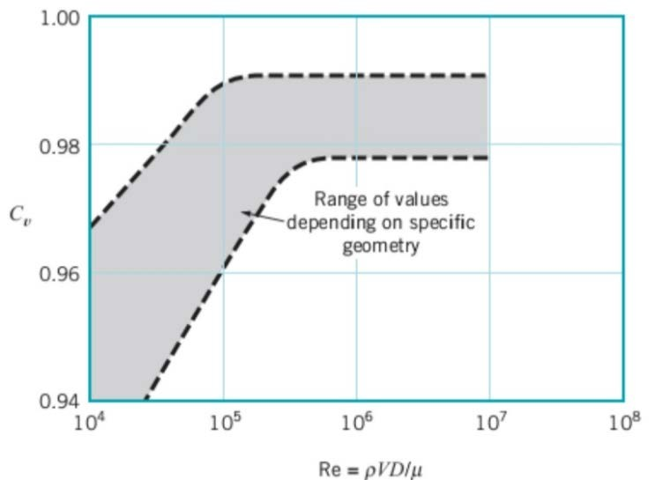

Figure 4: The co-efficient of discharge of a venturi meter

# 3.1.1 The Orifice Meter

The orifice meter consists of a throttling device (an orifice plate) inserted in the flow. This orifice plate creates a measurable pressure difference between its upstream and downstream sides. This pressure is then related to the flow rate. Like the Venturi meter, the pressure difference varies directly with the flow rate. The orifice meter is constructed as shown in Figure 5.

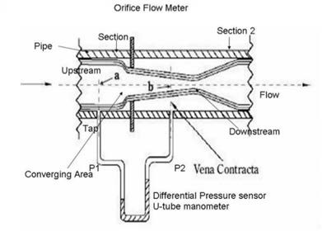

Figure 5: Cutaway view of the orifice meter The co-efficient of discharge is 0.62-0.67 for orifice meter.

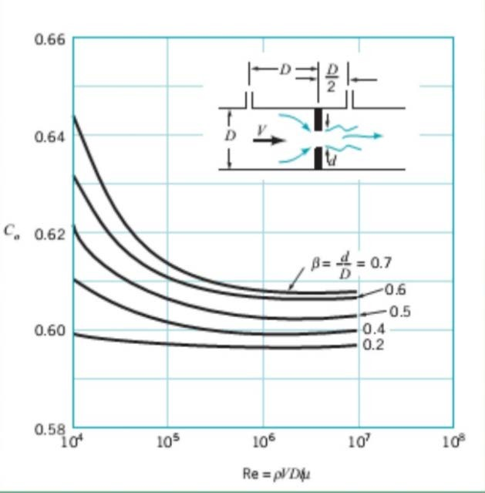

Figure 6: The co-efficient of discharge of an orifice meter.

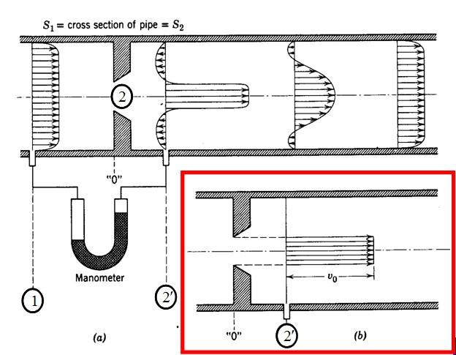

Figure 7:Figure 7. (a) The approximate velocity profiles at several planes near a sharp-edged orifice plate. Note: the jet emerging from the hole is somewhat smaller than the hole itself; in highly turbulent flow the jet necks down to a minimum cross section at

## 3.1.2 The Variable Area Meter (Rotameter)

A rotameter consists of a gradually tapered glass tube mounted vertically in a frame with the large end up. Fluid enters the tube from the bottom. As it enters, it causes the float to rise to a position of equilibrium. The position of equilibrium is at the point where the weight of the float is balanced by the weight of the fluid it displaces (the buoyant force exerted on the float by the fluid) and the pressure due to velocity (dynamic pressure).

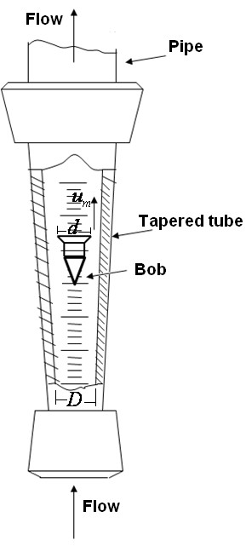The higher the float position the greater the flow rate. Note that as the float rises, the annular area formed between the float and the tube increases. Maximum flow is at maximum annular area or when the float is at the top of the tube. Minimum area, of course, represents minimum flow rate and is when the float is at the bottom of the tube.

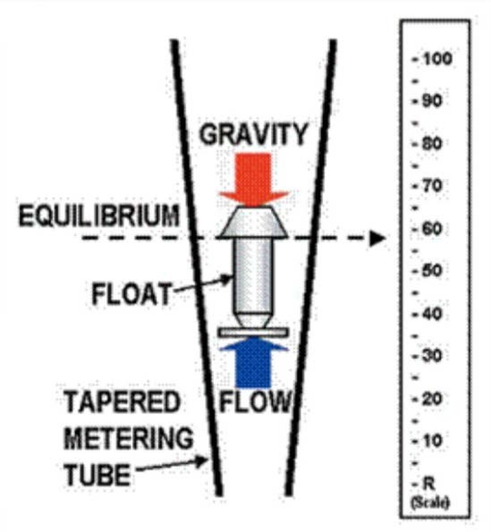

|  |
| --- |
| **(b)** |
| **(a)** |
|  |

Figure 8: (a,b) Rotameter

In balance conditions, the flow rate is expressed by the following formula:

2*V f* (* f*  ** )

*Af *

*Q* *Cd*

( *AT*

* *AF* ) 

(8)

Equation 8

where

Cd = coefficient of efflux At = pipe section

Af = maximum section of the float Vf = Volume of the float

ρf = density of the float ρ = density of fluid

# 4.0 EXPERIMENTS TO BE PERFORMED

The test unit will be introduced in the laboratory before the experiment by the relevant assistant.

# 4.1 Calculation of the coefficient of efflux of the calibrated diaphragm Aim of the Experiment:

* + - To find out the relationship between the flow rate and the load loss
    - To find the coefficient of efflux

The necessary data for calculations will be recorded to the table given below

Table 1: Calculation of the coefficient of efflux of the calibrated diaphragm

|  |  |  |  |  |  |  |  |  |  |  |
| --- | --- | --- | --- | --- | --- | --- | --- | --- | --- | --- |
| Qrot | Qvol | H1 | H2 | �∆𝐻𝐻1,2 | H3 | H4 | �∆𝐻𝐻3,4 | H5 | H6 | �∆𝐻𝐻5,6 |
|  |  |  |  |  |  |  |  |  |  |  |
|  |  |  |  |  |  |  |  |  |  |  |
|  |  |  |  |  |  |  |  |  |  |  |
|  |  |  |  |  |  |  |  |  |  |  |
|  |  |  |  |  |  |  |  |  |  |  |

**Calculations:** Using the equation given below, calculate the coefficient of efflux. The flow rate is defined as:

𝑄𝑄 = 𝐶𝐶𝑑𝑑 𝐴𝐴2 �2𝑔𝑔∆ℎ = � 𝐶𝐶𝑑𝑑 𝐴𝐴2 �2𝑔𝑔� √∆ℎ

�1−𝛽𝛽 4 �1−𝛽𝛽 4

Equation 9

Where:

𝐶𝐶𝑑𝑑 = 𝑐𝑐𝑐𝑐𝑐𝑐𝑐𝑐𝑐𝑐𝑐𝑐𝑐𝑐𝑐𝑐𝑐𝑐𝑐𝑐𝑐𝑐 𝑐𝑐𝑐𝑐 𝑑𝑑𝑐𝑐𝑑𝑑𝑐𝑐ℎ𝑎𝑎𝑎𝑎𝑔𝑔𝑐𝑐

𝛽𝛽 = 𝑑𝑑/𝐷𝐷

𝐴𝐴1 = 𝑝𝑝𝑐𝑐𝑝𝑝𝑐𝑐 𝑑𝑑𝑐𝑐𝑐𝑐𝑐𝑐𝑐𝑐𝑐𝑐𝑐𝑐

𝐴𝐴2 = 𝑎𝑎𝑐𝑐𝑑𝑑𝑐𝑐𝑎𝑎𝑐𝑐𝑐𝑐𝑐𝑐𝑐𝑐𝑐𝑐𝑐𝑐𝑐𝑐 𝑑𝑑𝑐𝑐𝑐𝑐𝑐𝑐𝑐𝑐𝑐𝑐𝑐𝑐

∆ℎ = 𝑙𝑙𝑐𝑐𝑎𝑎𝑑𝑑 𝑙𝑙𝑐𝑐𝑑𝑑𝑑𝑑 𝑐𝑐𝑐𝑐 𝑚𝑚

* + - Draw a relationship between the flow rate in y – axis and the load loss in x – axis
    - Carry out a linear interpolation and find the coefficient of efflux from the angular coefficient value of the obtained line.

# Calculation of the coefficient of efflux of the venturi meter Aim of the Experiment:

* + - To find out the relationship between the flow rate and the square root of the load loss
    - To find the coefficient of efflux

The necessary data for calculations will be recorded to the table given below.

Table 2: Calculation of the coefficient of efflux of the venturi meter

|  |  |  |  |  |  |  |  |  |  |  |
| --- | --- | --- | --- | --- | --- | --- | --- | --- | --- | --- |
| Qrot | Qvol | H1 | H2 | �∆𝐻𝐻1,2 | H3 | H4 | �∆𝐻𝐻3,4 | H5 | H6 | �∆𝐻𝐻5,6 |
|  |  |  |  |  |  |  |  |  |  |  |
|  |  |  |  |  |  |  |  |  |  |  |
|  |  |  |  |  |  |  |  |  |  |  |
|  |  |  |  |  |  |  |  |  |  |  |
|  |  |  |  |  |  |  |  |  |  |  |

**Calculations:** Using the equation given below, calculate the coefficient of efflux.

The flow rate is defined as:

𝐶𝐶𝑑𝑑 𝐴𝐴2

𝑄𝑄 =

�1 − 𝛽𝛽4

𝐶𝐶𝑑𝑑 𝐴𝐴2

�2𝑔𝑔∆ℎ = �

�1 − 𝛽𝛽4

�2𝑔𝑔� √∆ℎ

Equation 10

Where:

𝐶𝐶𝑑𝑑 = 𝑐𝑐𝑐𝑐𝑐𝑐𝑐𝑐𝑐𝑐𝑐𝑐𝑐𝑐𝑐𝑐𝑐𝑐𝑐𝑐𝑐𝑐 𝑐𝑐𝑐𝑐 𝑑𝑑𝑐𝑐𝑑𝑑𝑐𝑐ℎ𝑎𝑎𝑎𝑎𝑔𝑔𝑐𝑐

𝛽𝛽 = 𝑑𝑑/𝐷𝐷

𝐴𝐴1 = 𝑝𝑝𝑐𝑐𝑝𝑝𝑐𝑐 𝑑𝑑𝑐𝑐𝑐𝑐𝑐𝑐𝑐𝑐𝑐𝑐𝑐𝑐

𝐴𝐴2 = 𝑎𝑎𝑐𝑐𝑑𝑑𝑐𝑐𝑎𝑎𝑐𝑐𝑐𝑐𝑐𝑐𝑐𝑐𝑐𝑐𝑐𝑐 𝑑𝑑𝑐𝑐𝑐𝑐𝑐𝑐𝑐𝑐𝑐𝑐𝑐𝑐

∆ℎ = 𝑙𝑙𝑐𝑐𝑎𝑎𝑑𝑑 𝑙𝑙𝑐𝑐𝑑𝑑𝑑𝑑 𝑐𝑐𝑐𝑐 𝑚𝑚

* Draw a relationship between the flow rate in y – axis and the square root of the load loss in x – axis
* The slope of the best line is:

𝑆𝑆𝑙𝑙𝑐𝑐𝑝𝑝𝑐𝑐 = 𝐶𝐶𝑑𝑑 𝐴𝐴2�

2𝑔𝑔

𝐴𝐴 2

Equation 11

* Then, Calculate Cd

1 − �

2�

𝐴𝐴1

# Calibration of the variable area flowmeter

* + - Fill a graph with the measured flowrate with the rotameter against the one obtain using the volumetric tank.
    - Carry out a linear interpolation; the obtained straight line represents the calibration line of the flow meter

Table 3: Calibration of the variable area flowmeter

|  |  |  |  |  |  |  |  |
| --- | --- | --- | --- | --- | --- | --- | --- |
| Qrot (l/h) |  |  |  |  |  |  |  |
| V (l) |  |  |  |  |  |  |  |
| T (sec) |  |  |  |  |  |  |  |
| Qvol (l/h) |  |  |  |  |  |  |  |

# Measurement methods compression

* + - Using the coefficients of efflux determined in the exercises 4.1 and 4.2, carry out a series of measurements and calculate the measurements error for the flow meters.

# Comparing the load losses

* + - Using the data obtained, draw a graph with the load loss as function of the flow for three flow meters.

Table 4: Comparing the load losses

|  |  |  |  |  |  |  |  |  |  |
| --- | --- | --- | --- | --- | --- | --- | --- | --- | --- |
| Volume (l) | Time (sec) | Q  (l/h) | Qrot (l/h) | H1  (m) | H2  (m) | H3  (m) | H4  (m) | H5  (m) | H6  (m) |
|  |  |  |  |  |  |  |  |  |  |
|  |  |  |  |  |  |  |  |  |  |
|  |  |  |  |  |  |  |  |  |  |
|  |  |  |  |  |  |  |  |  |  |
|  |  |  |  |  |  |  |  |  |  |

5.0 CONCLUSION

The Venturi meter helped us understand measurement of discharge from a

pipe and to define relationships between different properties of fluid: effect of

viscosity on pressure losses, variation of pressure and velocity on different

cross- sections…

This experiment gave us a real understand of how to apply both Bernoulli

equation and Continuity equation and to study the Hydraulic Grade Line

(HGL) and Energy Line (EL) by plotting these results.

Objectives were all achieved but many errors were encountered during the

experiment and thus affected results.

References

(Street & , n.d.)

(Fiagbe, 2019)

(Serwaa, n.d.)

(Newton, 2005)

(Adukwei, 2019)

(Godsway, et al., n.d.)